Task 1.1 — Age Distribution: Deposit vs Non-Deposit Clients

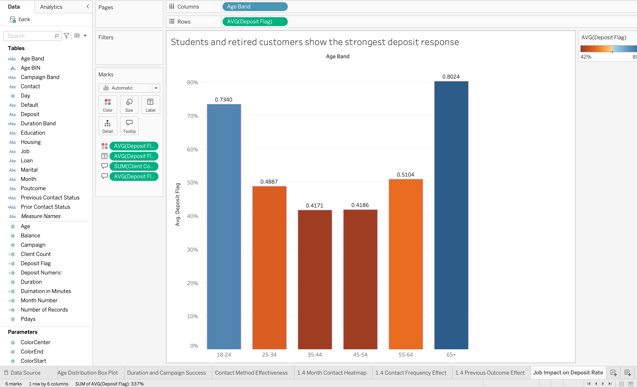What the Visualisation Shows
This bar chart displays the average deposit rate across six age bands (18–24, 25–34, 35–44, 45–54, 55–64, 65+) using a calculated Deposit Flag field averaged per band. The chart reveals a U-shaped pattern: the 18–24 band converts at 73.4% and the 65+ band at 80.2%, while the middle bands (35–44 at 41.7%, 45–54 at 41.9%) are substantially lower.

How It Is Presented

A vertical bar graph was used in the comparison of a quantitative variable across ordered categories (Munzner, 2014). The age categories have been arranged in ascending order in order to highlight the inverted-U trend. There is a two-color approach where dark brown is applied in the most high-performing categories while orange represents other categories, which contrasts using the pre-attentive property of hue (Few, 2009). Labels for percentages are displayed on top of the bars, and an explanatory title is used based on Tufte’s (2001) recommendation.

Key Insight
It is clear that the younger segment (18 to 24) and the senior one (65+) exhibit a considerably higher reaction rate compared to the middle age segment, which has the worst conversion rates.

Task 1.2 — Impact of Client Occupation on Deposit Likelihood

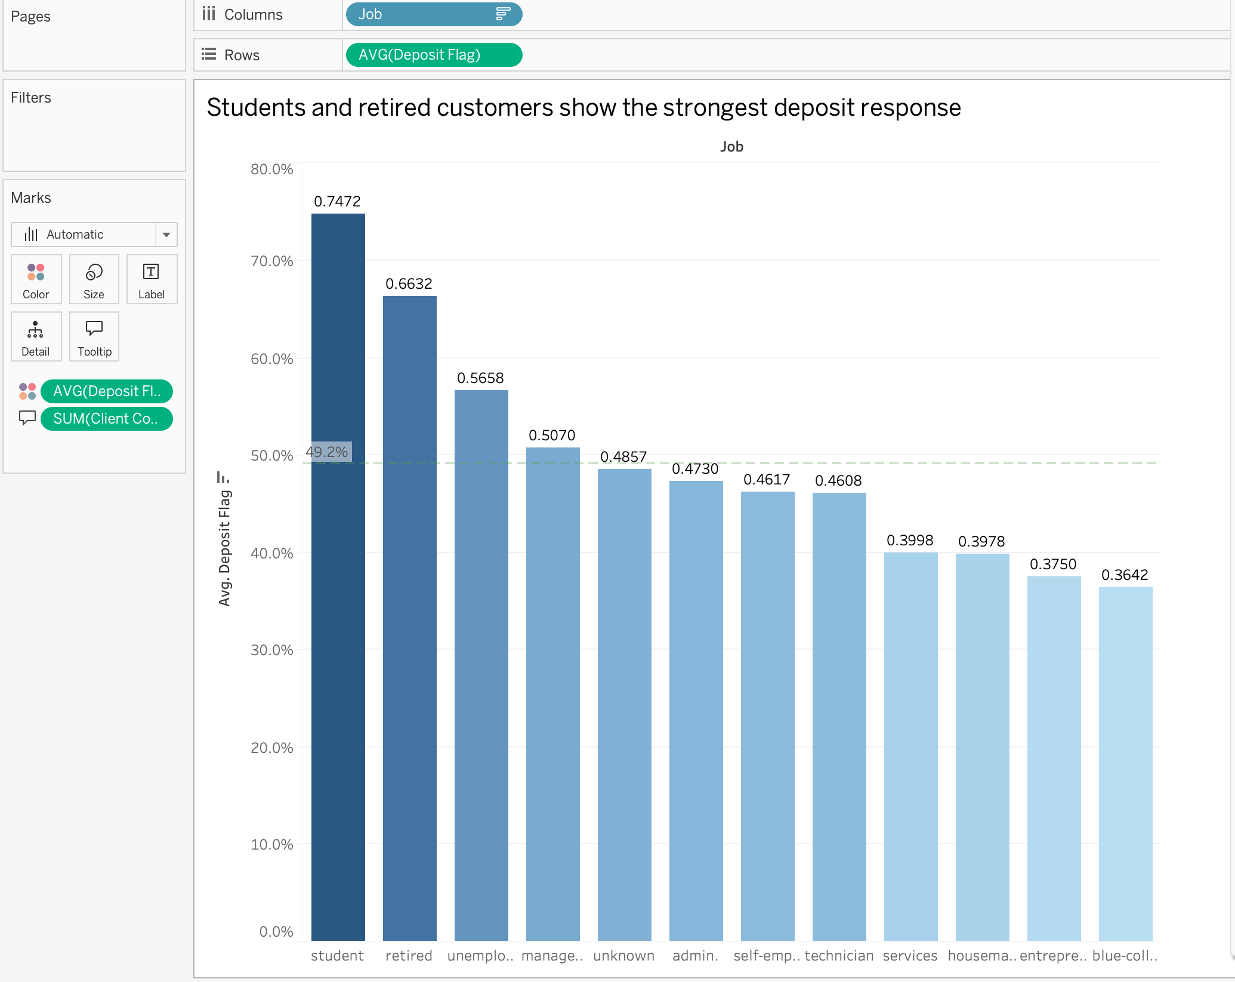What the Visualisation Shows

This is a horizontal bar graph showing the mean deposit rate by occupational group in descending order. The highest deposit rate is achieved by students, with 74.7%; retirees come second, with 66.3%, while unemployed clients have 56.6%. The lowest deposit rates are obtained by blue-collar employees and entrepreneurs, both with 36.4% and 37.5%, respectively.

How It Is Presented

A sorted horizontal bar graph is the best way to rank categories of information (Few, 2009). Averaging the Deposit Flag per job allows a fair comparison independent of the number of observations in each category. Sorting in descending order uses the Gestalt law of order. The average line is used as a guide, while client numbers can be obtained from a tooltip (Shneiderman, 1996).

Key Insight
Job category affects the chances of deposits but needs to be understood in conjunction with age, mode of contact, and previous results. Students and pensioners have the highest success rate, matching up with Task 1.1 because both groups contain individuals aged 18 to 24 and over 65 years old.

Task 1.3 — Influence of Contact Duration on Campaign Success

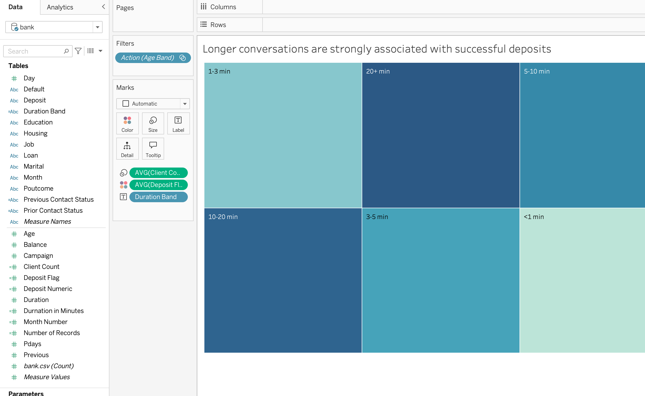What the Visualisation Shows
This bar chart displays the average deposit rate across six duration bands: under 1 minute, 1–3, 3–5, 5–10, 10–20, and 20+ minutes. Calls under one minute convert at about 1%, while those exceeding 20 minutes reach approximately 91%, showing a strong positive association.

How It Is Presented

A bar graph with user-defined Duration Band intervals was selected since binning minimizes noise for 11,162 data entries but retains the obvious positive trend (Munzner, 2014). Bands are arranged by duration in increasing order to highlight the progression through visual means. Percentage annotations above each bar enable exact readings. The caption clearly indicates the correlation to aid comprehension without the need for assumptions.

Key Insight
Duration is the best indicator of success. This variable, however, cannot be known before the call and can indicate customer interest rather than lead to a sale. This variable is better suited to be used for training purposes.
Task 1.4 — Campaign Strategy Dashboard

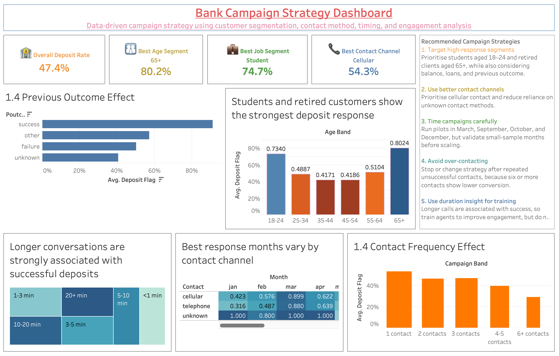What the Dashboard Shows

The dashboard called “Bank Campaign Strategy Dashboard” has all the analysis information presented strategically. There are four KPI cards that give the Overall deposit rate (47.4%), Best age segment (65+ at 80.2%), Best job segment (Student at 74.7%) and Best contact Channel (Cellular at 54.3%). Each card has an icon colour-coding. The body part consists of five coherent visualizations. The Previous Outcome Effect visualization is displayed in a horizontal bar chart form which says that clients who were contacted in a previous campaign converted over 91%. It is confirmed that the Age Band distribution follows the U-shape rule. Treemap visualization divides calls into groups based on their duration by tile sizes and teale colour range. A cross-tabulation of Month-Contact is done via heatmap that reveals March to be the top converting month among all other months. The Contact Frequency bar chart indicates a downward trend beginning from 53% to 29%.

How It Is Presented

The dashboard is designed on a grid structure to ensure that no element is hidden from view by scrolling, conforming to Shneiderman’s (1996) overview first approach. The KPI cards use large, color-coded typefaces and icons for immediate identification. In the Previous Outcome graph, the colors used are red for success, orange for others, blue for failures, and teal for unknowns. For the Age Group graph, the best performing categories are represented using dark brown colors while the mid-level performing categories are represented using orange colors. The treemap employs tile size based on volume with a sequential teal scale. In the heat map, there is a sequential variation in colors, which is the preferred form of encoding quantitative matrices (Munzner, 2014).

Recommended Strategies

• Target responsive audiences: focus on students aged 18-24 and retired customers aged 65+, along with consideration for balance, loans, and past performance.

• Improve communication means: emphasise cellular means (54.3%), while minimising other communication channels.

• Timing matters: launch test campaigns in March, September, October, and December, but confirm small-scale month validity first.

• Maintain balance: avoid or alter the approach upon multiple failed contacts, since six or more contacts indicate poor conversion.

• Leverage call duration analysis for training: extended calls indicate successful outcomes; hence, train agents for better interaction, but exclude call duration from pre-call targeting.

Ethical Considerations
The age of the consumer and their profession can serve as an indicator for the marketing message regarding customers’ needs, but discrimination must not take place by excluding certain groups from participation in the marketing process. The customer must have the freedom to opt out of receiving messages, and the frequency must not be excessive.

